BSc (Hons) Mental Health Nursing

Interview instructions for applicants

These guidelines are for applicants who, as part of the application process for BSc (Hons) Mental Health Nursing, have been invited to attend an interview day at the University of Suffolk.

Interview day schedule
Please arrive at the Waterfront Building Reception desk on the ground floor by 8:45am on the day of your interview.

The selection day is set out in a ‘Multi Minute Interview’ format where candidates rotate around several stations which are designed to enable maximum demonstration of skills and attributes relevant to mental health nursing. During the rotation, the candidate will be engaging in various activities as well as some mini panelled interviews as part of some of the stations.

The panel of interviewers will be made up of the nursing and midwifery team, practice partners, admissions personnel and maybe service users or current students.

During the selection day, candidates will have the opportunity to tour the campus, meet other potential candidates, meet, and greet current mental health nursing students, ask questions of the team/university personnel, as well as partaking in the multi-minute interviews.

The selection day is scheduled to end at 3:40PM, however please be aware that the end time is variable based upon the number of applicants in attendance at your selection day.
Important information
Interviews are designed to assess the following:

- Effective communication and interpersonal skills.
- Evidence of values which reflect knowledge and understanding of the importance of equality, diversity, fairness, dignity, respect, and compassion, including NHS values. Your transferable and problem-solving skills.
- Your understanding of the requirements and responsibilities of being a student nurse on a professional course.
- Your understanding of the role of the Registered Mental Health Nurse.
- Your motivation and commitment to undertake a professional nursing course.
- Your potential to cope with the academic and practical demands of the BS (Hons) Mental Health Nursing course, including being able to travel to attend practice placements. The below map shows the area our Practice Partners cover, most placements are located across East and West Suffolk:
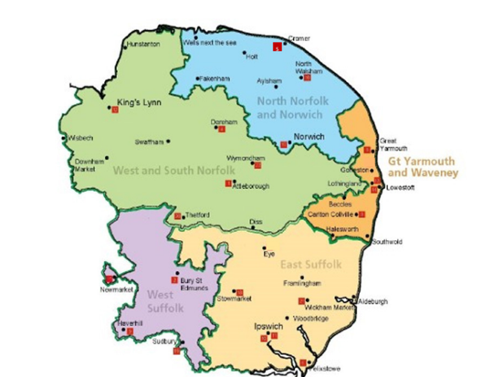

Outcomes from the interview process could be
Offer: Conditional/Unconditional | Alternative course offer | Reject
Feedback to those unsuccessful candidates is available on request via the Admissions office only. Please email admissions@uos.ac.uk and your request will be forwarded to the Admissions Tutor for reply.

Suggested Resource List:
You may find the resources below useful in preparing for the interview. You may also wish to refer to current articles and reports in publications which are concerned with health and social care delivery, within hospital and community settings. Additionally, you may contact your local hospital/community volunteering section to explore possible opportunities for gaining experience or, insights into the nursing role. You should be able to find contact details in your local library or via organisation websites.

There are a number of textbooks and websites available to support you in developing and practicing basic numerical skills relevant to nursing and your application.

Some useful websites are:

Rethink Mental Illness
Home - Mind

www.nmc.org.uk
RCN - Home | Royal College of Nursing
Department of Health and Social Care - GOV.UK (www.gov.uk)
Health Careers |
International Council of Nurses (ICN) | ICN - International Council of Nurses
World Health Organization (WHO)
The NHS website - NHS (www.nhs.uk)
Nursing Times: Resources for the Nursing Profession
Nursing Standard (rcni.com)

Please note: These links are suggested as a general guide only and are not specifically endorsed or published by the University of Suffolk; this is also not an exhaustive list, and you should ensure that you prepare for your interview fully through wider reading.

We hope that you will find this information useful. However, if you require any additional information, please do not hesitate to contact the Student Centre (01473 338833 or studentlife@uos.ac.uk), where the staff will be happy to assist you.

Finally, we look forward to speaking with you soon and wish you well in interview. Please give yourself the best chance of success, by ensuring that you are well prepared.

Best wishes on behalf of the Course and Admission teams

Clair Piper
Admissions Tutor

